Technical Report

Md. Raihan Tapader

Executive Summary:
This project focuses on analyzing housing data to predict house prices and compare two predictive models Linear Regression and XGBoost. The dataset used, “House Price.xlsx”, contains 205 records of different houses with 22 columns, including size, age, quality, and various other characteristics. Through careful data cleaning, exploratory data analysis (EDA), and machine learning model implementation, both models were trained and evaluated using R² Score and RMSE. The results show that XGBoost achieved the best performance, identifying living area size and overall quality as the most influential factors affecting house prices. This analysis provides valuable insights for both real estate professionals and homeowners, helping them better understand the key elements that drive property value. The dataset overview are given in below:
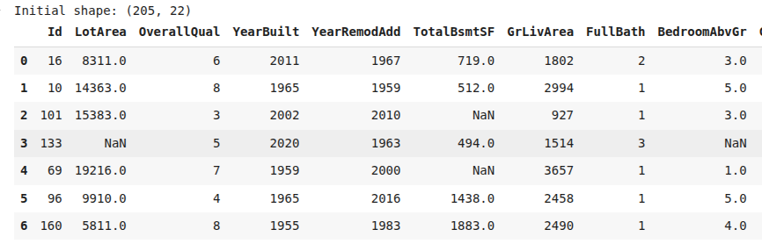
Fig 1: Dataset overview
Dataset Overview:
- Original dataset shape: (205, 22)
- After cleaning: (200, 22)
- Features processed: 33
- Target variable: SalePrice

What I did in this project?
1. Data Cleaning
- Fixed missing values and removed duplicates
- Checked for logical errors (like remodeling before building).
- Year inconsistencies corrected.

2. Perform EDA
- Find out the correlations of each features with sale price, distributions graph and outliers identification and show outlier box plot for better understanding.
- Identified that bedroom count surprisingly doesn't affect price much
- Find out the correlation of house price and other columns, datadistribution

3. Feature Engineering
- Created new helpful features ratios
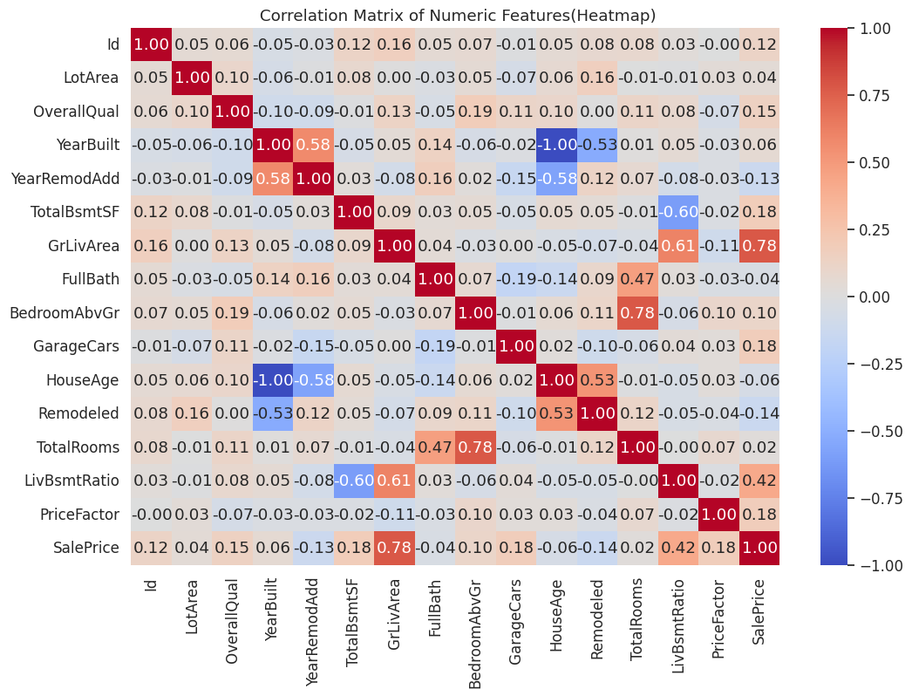
- Converted text categories to numbers, normalize numerical features
- Generate heatmap to understand the relationship wih other feature and saleprice

4. Model Implementation
- Built two prediction models: Linear Regression and XGBoost
- XGBoost performed better at predicting prices accurately
- Used proper evaluation metrics (RMSE and R² Score)
- Train data 80% and Test is 20%

5. Hyperparameter Tuning
- I used GridSearchCV to try many combinations of XGBoost hyperparameters
- Avoid overfitting prefer simpler models smaller max_depth, lower subsample if test performance lags behind CV.
- The best parameters were learning_rate=0.05,max_depth=3,n_estimators=300, and subsample=0.5 for XGBoost.
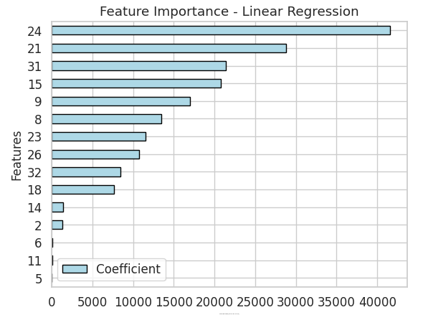

Fig: Illustrate the most affecting features for the price in Linear Regression Model
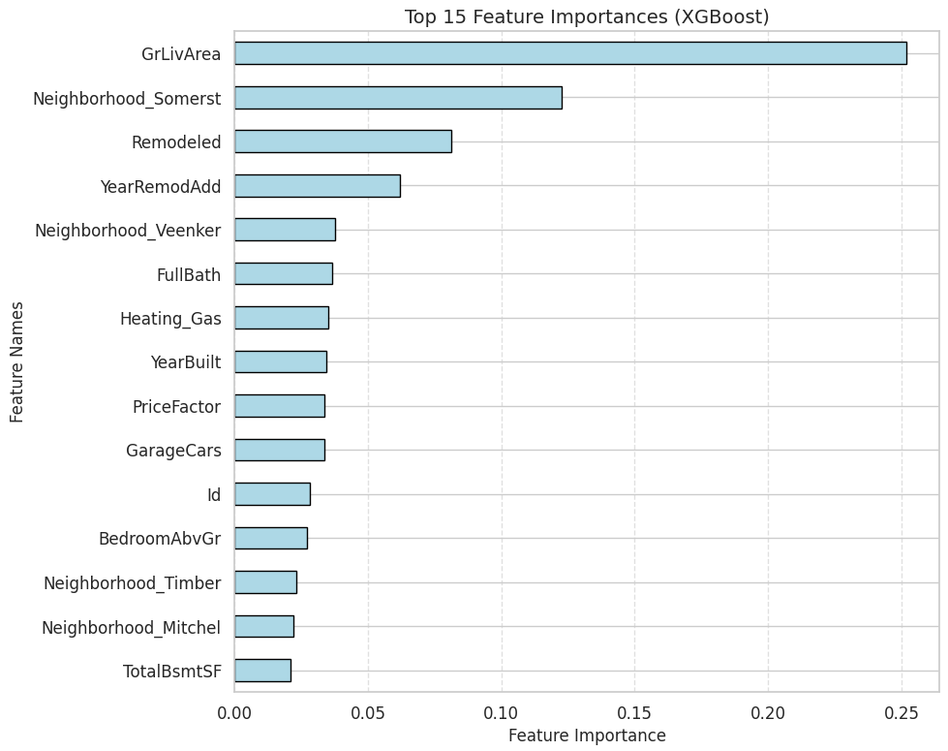
Fig: Demonstrate the Top features affecting SalePrice in XGBoost Model

Results:
Table:Performance Comparison
Model | RMSE | R² Score | Hyperparameter Tuning ( Best CV score
Linear Regression: | 85210.09 | 57.06% | 74.84%
XGBoost | 82151.26 | 60.09% | 71.78%

Explaining which model performed better and why?
From the results, I can see that the XGBoost model performed better than Linear Regression overall because:
- Lower RMSE (82,151 vs. 85,210) means XGBoost made smaller prediction errors on average. A lower RMSE indicates that XGBoost’s predictions are closer to real house prices on average.
- Higher R² Score (60.09% vs. 57.06%) indicates XGBoost explained more variation in house prices. This means XGBoost explains around 3% more variance in the target variable (SalePrice), showing better predictive power.
Although Linear Regression achieved a slightly higher cross-validation (CV) score during hyperparameter tuning, XGBoost showed stronger performance on actual predictions on the test data.
This is because XGBoost is an advanced tree-based ensemble algorithm that can capture non-linear relationships between features such as house size, age, quality, and neighborhood. It builds multiple decision trees sequentially, where each new tree corrects the errors of the previous one. This allows it to capture subtle feature interactions (e.g., how “living area” and “overall quality” together affect price). XGBoost also includes regularization, which helps prevent overfitting meaning it performs well not just on training data but also on new, unseen data.
In contrast, Linear Regression assumes a straight-line relationship, which limits its ability to model complex patterns in the data. While it is simple and interpretable, it struggles to capture non-linear patterns or interactions between features. For example, the price increase may not always be proportional to area — luxury features or neighborhood quality might cause sudden jumps that Linear Regression cannot handle well.
Overall, XGBoost proved to be the more accurate and robust model for predicting house prices in this dataset.

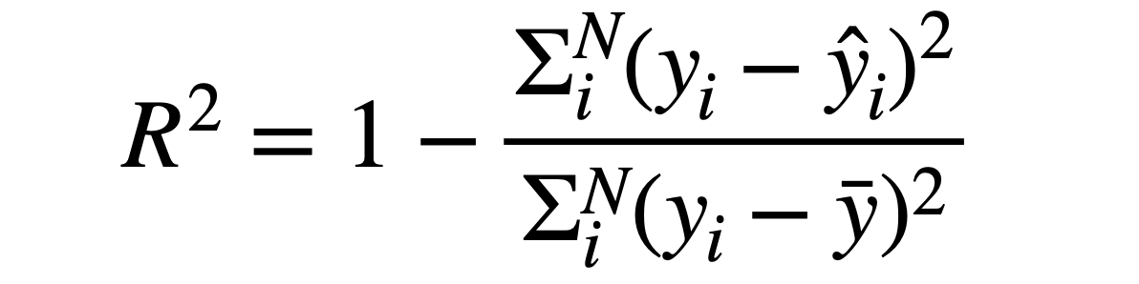
R² Score : It indicates the proportion of the variance in the dependent variable that is predictable from the independent variables.

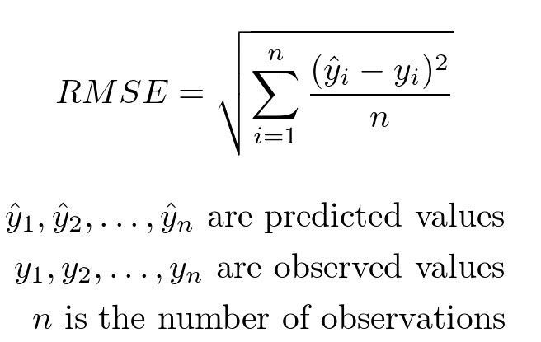
RMSE: measures how far the predicted prices are from the actual prices.

Limitations & Future Work:

Dataset limited to 200 properties, larger dataset could improve accuracy.

External factors (market trends, economic conditions) not included.

Potential for incorporating geographic and amenity data.

Real-time price adjustment capabilities for dynamic markets.

Conclusion:
This project successfully demonstrated how data-driven approaches can be applied to predict house prices with strong accuracy and practical relevance. The analysis revealed that living area size, overall quality, and location-related factors are the most influential variables affecting property prices. These findings provide valuable insights for real estate professionals, investors, and homeowners to make more informed decisions regarding property valuation and market trends.
I genuinely enjoyed working on this project, as it strengthened my understanding of machine learning fundamentals, including data preprocessing, model training, and evaluation. The process enhanced both my technical and analytical skills, and I gained greater confidence in applying data science techniques to solve real-world problems.

